Academic activities together with community engagement
IOPP624 – Practical Psychometrics

Project in collaboration with Department of Social Development (DSD) in Sebokeng

An alumni member of NWU Vanderbijlpark, now a Statutory Social Worker employed by Department of Social Development (DSD) in Sebokeng, Ms Hloni Mohalanyane contacted me via email with a request for job readiness training for a group of orphans under her care. I interacted with her as a student during 2015 and 2016 while working in SCD and the Career Centre.

Consultation and needs analysis resulted in a project beneficial for all parties involved. An intern in Industrial Psychology employed by NWU compiled a workbook and workshop in job readiness, CV writing and interview preparation – presented and trained the learners and the students on it, and also upskilled the students to facilitate discussions; the Student Psychometrists (12 x IP Honours students) administered three career guidance psychometric assessments, scored and interpreted the findings, wrote a report on the results and provided individual feedback to each learner, as well as acted out role-plays to showcase good and bad interviews; Twelve out of fifteen invited learners between the ages of 16 and 22 showed up an participated in all the events that took place over two days in August-September. They are now able to use everything they’ve learned about themselves in the assessments, as well as what was presented in the workshop, and apply it in their job hunting endeavours and/or application for tertiary studies. I was the supervising psychologist for all parties involved ~ Elette van den Berg.
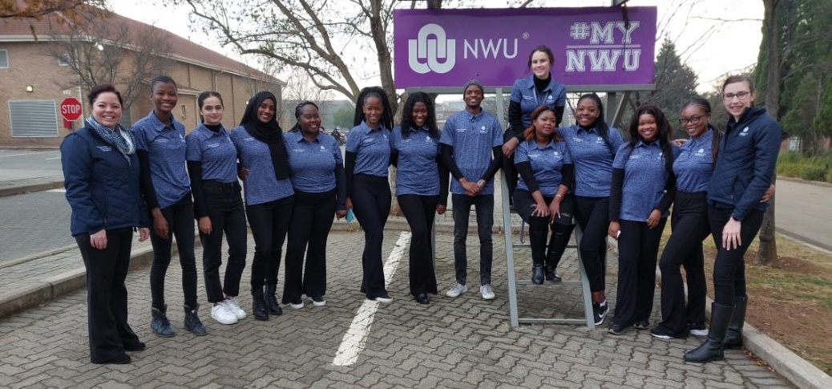

The picture on the right was taken on 4 August 2022 before we left campus to travel to DSD Offices in Sebokeng. The supervisor, intern IOP and student psychometrists are all visible in the picture.

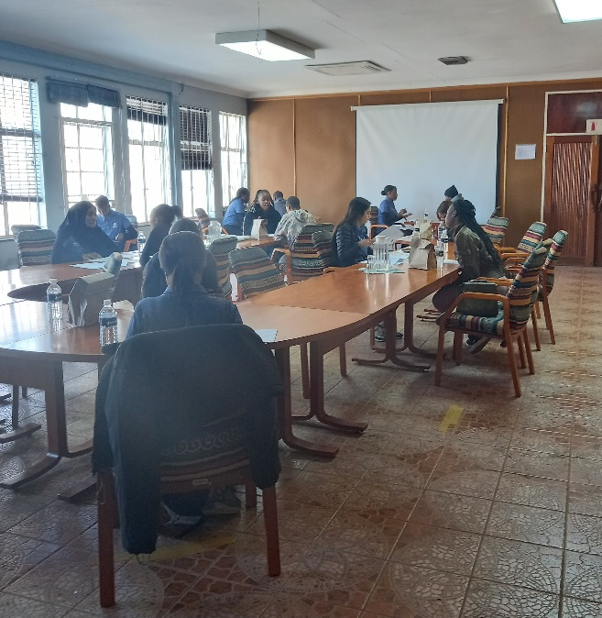

The picture on the left was taken on 1 September 2022 and display student psychometrists providing feedback on psychometric results to each of the different learners. (POPI guidelines – only faces of students are visible and they consent to share).

